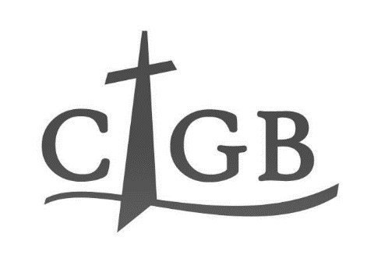
Gift Aid form

£

I wish to make a donation to the Churches and Industry Group Birmingham of

Please confirm the amount in words _________________________________________________

(Cheques should be made payable to CIGB)

Declaration
Please
Tick box

I am a UK taxpayer paying Income Tax or Capital Gains Tax, intending tax to be
reclaimed on the above donation to CIGB made under the Gift Aid scheme.

Signed _______________________________________________ Date ___________________

Please print your details below

Title _______ Forename(s) ____________________________________________________

Family name ______________________

Full address Telephone number _________________

________________________________________ E-mail address

________________________________________ _________________________________

_____________________ Post code _________

